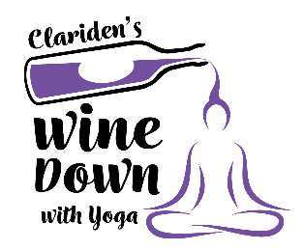
Join us for our first Wine Down With Yoga adult only event on Saturday, November 7th, 2020 that will benefit The Clariden School. Enjoy fun, accessible yoga sequences with wine tasting breaks throughout as rewards! Throwback tunes bring the energy. We just need YOU in comfortable clothes ready to move and breathe… and possibly be ready to sing-a-long a time or two. The fun will begin at 6:00 PM in the Swienton Family Gym and will end approximately 7:30. On behalf of the students and teachers at the Clariden School, THANK YOU!!!

SPONSORSHIP LEVELS & BENEFITS
$1,500 PRESENTING SPONSOR
- Prominent unshared signage at Wine Down With Yoga.
- Public address to guests prior to the beginning of the event.
- Logo on all invitations and promotional materials.
- Recognition on website and social media
- Logo on Yoga Mat Bag
- Six (6) Wine Down With Yoga tickets

$500 Yoga Mat Sponsor

$250 SPONSOR
- Recognition on website, social media and promotional materials
- Two (2) Wine Down With Yoga tickets

Wine SPONSOR (one)
- Signage recognition at the event
- Sponsor name listed on invitations & promotional materials
- Recognition on website and social media
- Two (2) Wine Down With Yoga tickets

- Recognition on website and social media
- Logo on invitations and promotional materials
- Logo/Name placed on the mat bag
- Four (4) Wine Down With Yoga tickets

2020 Sponsorship Agreement
Name (company, individual):____________________________________________________________________
Address: __________________________________ City:_________________________ State: ______ Zip:_______
Phone: ____________________________________________ Fax:________________________________________
Contact Person: ______________________________________________________ Date: ___________________
Email: __________________________________________________________________________________________
List in printed material as: _______________________________________________________________________

PLEASE INDICATE YOUR DESIRED LEVEL
_____ $1,500 – Presenting Sponsor (6 tickets to Wine Down With Yoga)
_____ $500 – Yoga Mat Sponsor (4 tickets to Wine Down With Yoga)
_____ $250 – Sponsor (2 tickets to Wine Down With Yoga)
_____ Wine Sponsor (2 tickets to Wine Down With Yoga)
_____ $50 Additional tickets (all tickets include Yoga Mat, wine samplings, and FUN!)

Your Billing Information
Please invoice me for $__________________________________on (Date) ______________________________
Please charge me $____________________on my _____MC_____Visa_____
Acct. #__________________________________________________Exp. Date ________
Print Name as it appears on card: _______________________________________________________________
Signature: ______________________________________________________________________________________
Kindly make checks payable to: The Clariden School
A tax-exempt, not-for-profit 501(c)3. Tax ID #75-2599601

